**1). Write a C program to interchange two numbers. (with and without using temporary variable) .**

**CODE 1aa:**

/*Write a C program to interchange two numbers. (with using temporary variable)*/

#include <stdio.h>

#include <conio.h>

int main()

{

int a, b, temp;

printf("Enter The First Number :");

scanf("%d", &a);

printf("Enter The Second Number :");

scanf("%d", &b);

temp = b;

b = a;

a = temp;

printf("After Swaping,The First Number Is %d.\n", a);

printf("After Swaping,The Second Number Is %d.\n", b);

return 0;

}

**OUTPUT 1a:**

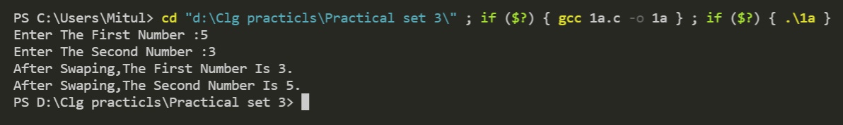

**CODE 1b:**

/*Write a C program to interchange two numbers. (without using temporary variable)*/

#include <stdio.h>

#include <conio.h>

int main()

{

int a, b;

printf("Enter The First Number :");

scanf("%d", &a);

printf("Enter The Second Number :");

scanf("%d", &b);

a=a-b;

b=a+b;

a=b-a;

printf("After Swaping,The First Number Is %d.\n", a);

printf("After Swaping,The Second Number Is %d.\n", b);

return 0;

}

**OUTPUT 1b:**

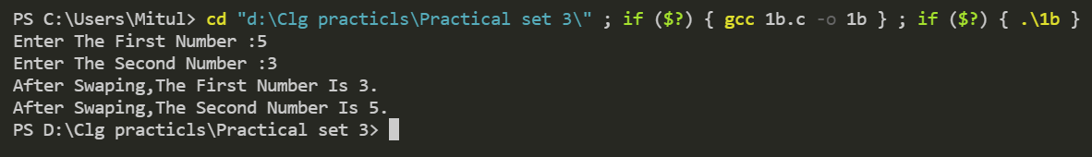

**2). Write a C program to enter a distance in to kilometre and convert it in to meter, feet, inches and centimetre.**

**CODE 2:**

/*Write a C program to enter a distance in to kilometre and convert it in to meter, feet, inches and

centimetre*/

#include<stdio.h>

#include<conio.h>

int main()

{

float km,kmtometer,kmtofeet,kmtoinches,kmtocm;

printf("Enter The Distance In To Kilometre : ");

scanf("%f",&km);

kmtometer=1000*km;

kmtofeet=3280.84*km;

kmtoinches=39370.1*km;

kmtocm=100000*km;

printf("Distance In Meter Is %f\n",kmtometer);

printf("Distance In Feet Is %f\n",kmtofeet);

printf("Distance In Inches Is %f\n",kmtoinches);

printf("Distance In CM Is %f\n",kmtocm);

return 0;

}

**OUTPUT 2:**

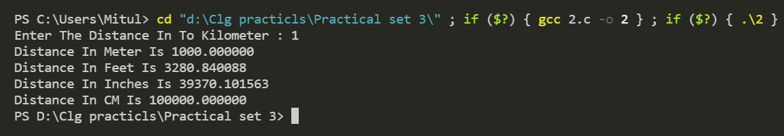

**3). Write a program to compute Fahrenheit from centigrade.**

**(f=1.8*c +32)**

**CODE 3:**

/*Write a program to compute Fahrenheit from centigrade (f=1.8*c +32)*/

#include <stdio.h>

int main()

{

float f, c;

printf("Enter The Temperature In Centigrade : ");

scanf("%f", &c);

f = (1.8 * c) + 32;

printf("The Value Of Centigrade In Fahrenheit Is %f", f);

return 0;

}

**OUTPUT 3:**

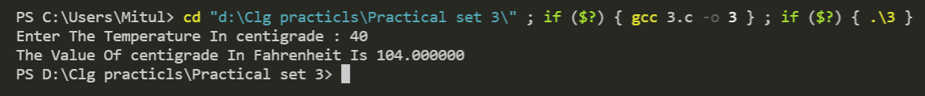

**4). Write a C program to find out distance travelled by the equation**

**d = ut + at^2**

**CODE 4:**

/*Write a C program to find out distance travelled by the

equation d = ut + at^2*/

#include <stdio.h>

int main()

{

float u, t, a, d;

printf("Enter The Value Of Initial Velocity : ");

scanf("%f", &u);

printf("Enter The Value Of Time Duration : ");

scanf("%f", &t);

printf("Enter The Value Of Acceleration : ");

scanf("%f", &a);

d = (u * t) + (a * t * t);

printf("Distance Is : %.2f", d);

return 0;

}

**OUTPUT 4:**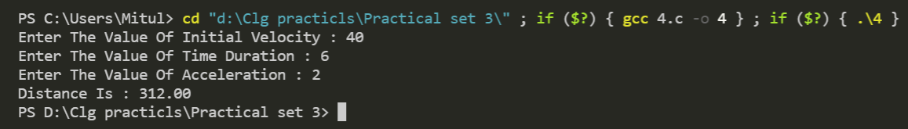

**5) Write a program to demonstrate use of all types of operators.**

**CODE 5:**

/* Write a program to demonstrate use of all types of operators*/

#include <stdio.h>

int main()

{

int a = 9,b = 4, c;

printf("The Value Of a=9\n");

printf("The Value Of b=4");

c = a+b;

printf("a+b = %d \n",c);

c = a-b;

printf("a-b = %d \n",c);

c = a*b;

printf("a*b = %d \n",c);

c = a/b;

printf("a/b = %d \n",c);

c = a%b;

printf("Remainder when a divided by b = %d \n",c);

return 0;

}

**OUTPUT 5:**